** EAST WEST UNIVERSITY**

**Experiment No:** 04

**Course Code:** ICE470

**Course Title:** Numerical Method Lab

**Experiment Name:** Root Finding using Naive Gauss Elimination.

**Submitted To:**

Mr. Rasel Ahmmed  
 Lecturer, Department of ECE

**Submitted by:**

Md. Tariqul Islam  
**ID NO:** 2014-2-50-021

**Date of Performance**: 30.05.2018

**Date of Submission:** 05.07.2018

**Experiment No: 04**

**Experiment Name:** Root Finding using Naive Gauss Elimination.

**Objective:**

**1.** To find out the root through gauss elimination.

**2.** To compare the real and estimated error.

**1. Matlab Code :**

clc;

close all;

clear all;

%solve Ax=b using naive gauss Elimination

A=[1.4 -1.2 -2.1;-4.2 -2.5 3.7;2.6 -3.1 1.7];

B=[-2.3;2.9;7.8];

%Augment matrix

Aug=[A,B];

%Piovat element is A(1,1)

c=Aug(2,1)/Aug(1,1)

Aug(2,:)=Aug(2,:)-c*Aug(1,:);

c=Aug(3,1)/Aug(1,1);

Aug(3,:)=Aug(3,:)-c*Aug(1,:);

%Piovat element is A(2,2)

c=Aug(3,2)/Aug(2,2);

Aug(3,:)=Aug(3,:)-c*Aug(2,:);

%Back substitution

x3 =Aug(3,4)/Aug(3,3);

x2 =(Aug(2,4)-Aug(2,3)*x3)/Aug(2,2);

x1 =(Aug(1,4)-Aug(1,2)*x2-Aug(1,3)*x3)/Aug(1,1);

fprintf('Using Naive gauss Elimination x1 is =%f \n' ,x1);

fprintf('Using Naive gauss Elimination x2 is =%f \n' ,x2);

fprintf('Using Naive gauss Elimination x3 is =%f \n' ,x3);

%plot

syms x1 x2 x3

ezsurf((-2.3-1.4*x1+1.2*x2)/(-2.1)),[10,-10];

hold on

ezsurf((-2.9+4.2*x1+2.5*x2)/(3.7)),[10,-10];

hold on

ezsurf((7.8-2.6*x1+3.1*x2)/(1.7));

hold on

**Command Window :**

c = -3.0000

Using Naive gauss Elimination x1 is =1.321535

Using Naive gauss Elimination x2 is =-0.246686

Using Naive gauss Elimination x3 is =2.117225

**Figure :**

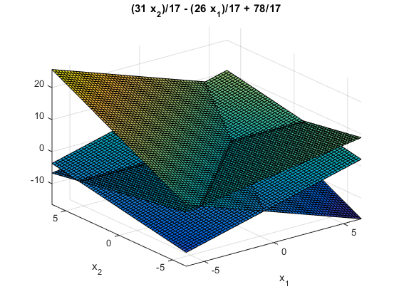

**2. Matlab Code (Practice) :**

clc;

close all;

clear all;

%solve Ax=b using naive gauss Elimination

A=input('enter the value of A:');

B=input('enter the value of B:');

%Augment matrix

Aug=[A,B];

%Piovat element is A(1,1)

c=Aug(2,1)/Aug(1,1)

Aug(2,:)=Aug(2,:)-c*Aug(1,:);

c=Aug(3,1)/Aug(1,1);

Aug(3,:)=Aug(3,:)-c*Aug(1,:);

%Piovat element is A(2,2)

c=Aug(3,2)/Aug(2,2);

Aug(3,:)=Aug(3,:)-c*Aug(2,:);

%Back substitution

x3 =Aug(3,4)/Aug(3,3);

x2 =(Aug(2,4)-Aug(2,3)*x3)/Aug(2,2);

x1 =(Aug(1,4)-Aug(1,2)*x2-Aug(1,3)*x3)/Aug(1,1);

fprintf('Using Naive gauss Elimination x1 is =%f \n' ,x1);

fprintf('Using Naive gauss Elimination x2 is =%f \n' ,x2);

fprintf('Using Naive gauss Elimination x3 is =%f \n' ,x3);

%plot

syms x1 x2 x3

ezsurf((7*x1+2*x2)/(3)),[10,-10];

hold on

ezsurf((4-2*x1-x2)/(1)),[10,-10];

hold on

ezsurf((-10+3*x1-2*x2)/(-2));

hold on

**Command Window :**

enter the value of A:[1 -2 3; 2 1 1; -3 2 -2]

enter the value of B:[7; 4; -10]

c = 2

Using Naive gauss Elimination x1 is =2.000000

Using Naive gauss Elimination x2 is =-1.000000

Using Naive gauss Elimination x3 is =1.000000

**Figure:   
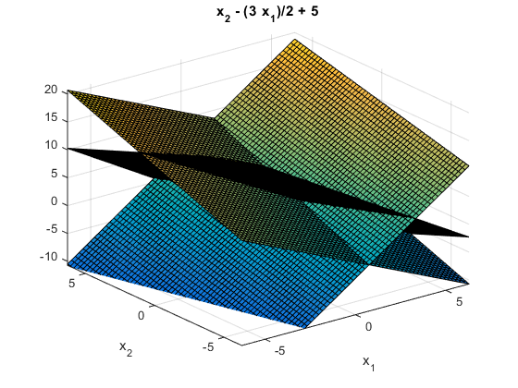  
  
  
Discussion:** This experiment name is Root Finding using Naive Gauss Elimination. Naive Gauss Elimination is one of the numerical techniques for solving simultaneous linear equations. There are two program codes. The 1st one program code was given as lab manual and the 2nd program code was done as practice program code. In the 1st program code x1, x2 and x3 value has been defined. Given equation,

1.4x1-1.2x2-2.1x3 = -2.3;

-4.2x1-2.5x2+3.7x3 = 2.9;

2.6x1-3.1x2+1.7x3 = 7.8;

In this method need to reduce the coeficient matrix [A]. The value of A and B is written in the program code. Then eliminated x1 from the 2nd to 3rd equation and eliminated x2 from the 3rd equation. Continue process until the nth equation has only 1 Non-Zero coefficient. Then got to know the value of x3. Also get to know the value of x2 then x1. Then there is a figure for the 1st program code which shows 3-D colored surface plotter because in the program code there is a function named ezsurf. There is one more function which is hold on that means retains the current plot and certain axes properties so that subsequent graphing commands add to the existing graph. If I don’t write the function hold on in the program code then the full figure of the colored surface will see as one surface not like the three surfaces as now looking in the figure.   
The practice program code is same as the 1st program code. For the 2nd program code the given equation,

x1-2x2+3x3 = 7;

2x1+x2+x3 = 4;

-3x1+2x2-2x3 = -10;

Here, just need to put the value of A and B as a user. So, for this there is a function in this program code named input. After entering the value of A and B in matrix form as a user then get to know the value of c and x1, x2, x3. For this program code there is also a figure. This code is easy to perform but need to be attentive while doing codes and have to know about Naive Gauss Elimination correctly otherwise there will be problem in writing codes.